**Website Project**

**1. How To Create Website**

**Creating website on GitHub**

**Basic Steps for Hosting Website on GitHub**

**Step 1: Create a GitHub account**

The first step is to create a GitHub account if you don’t have one already. You can create an account for free on the GitHub website.

If you already have one then do **github login** to your account.

Goto <https://github.com/>

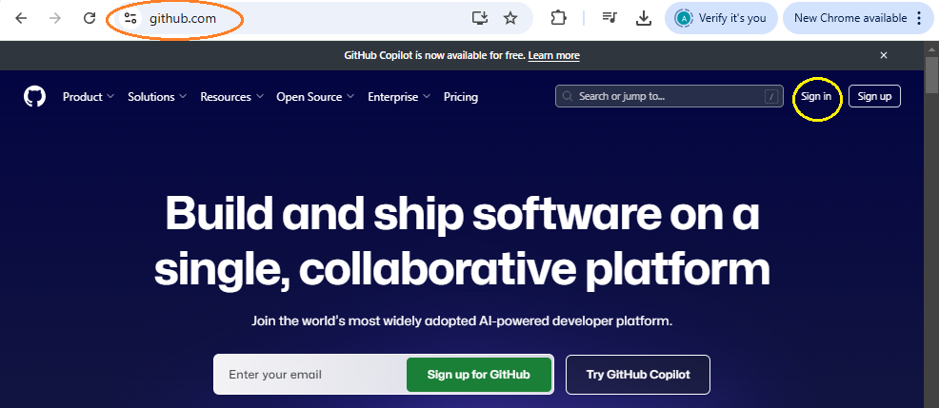

Click Sign in

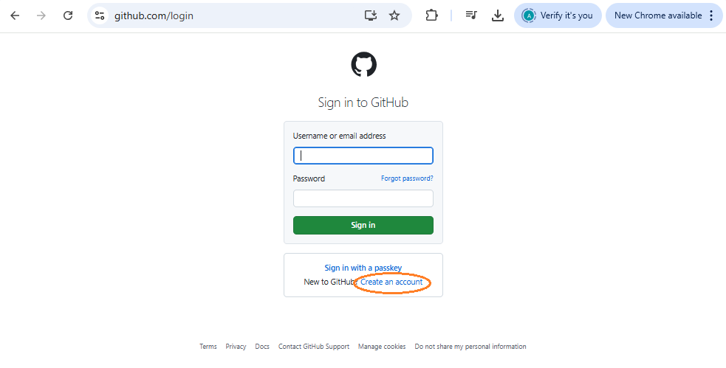

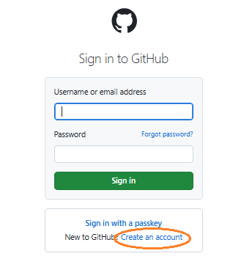

Using [aaaaakom@outlook.com](mailto:aaaaakom@outlook.com) email address for subscribe our login name.

Give your Pwd : ___________

Username: akomweb2025 this user name is our login name and our address in the server (https://akomweb2025.github.io/myWebpage/).

Password should be at least 15 characters OR at least 8 characters including a number and a lowercase letter.

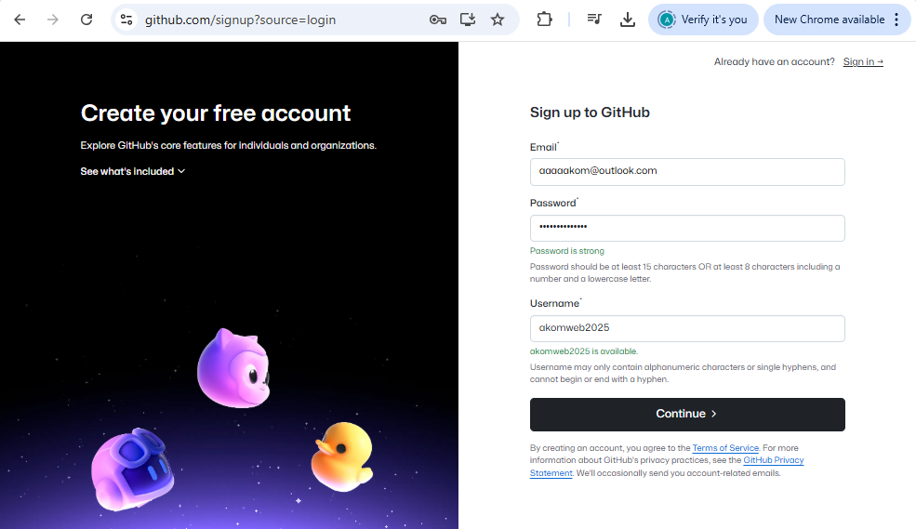

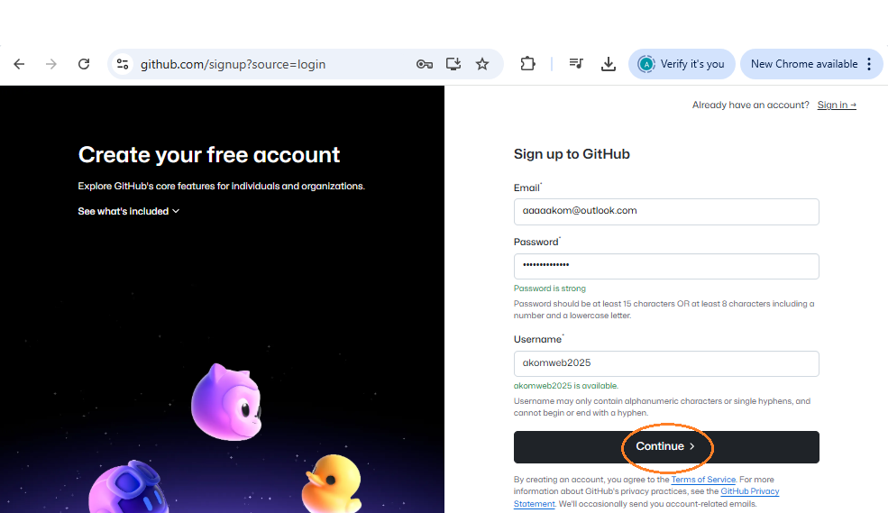

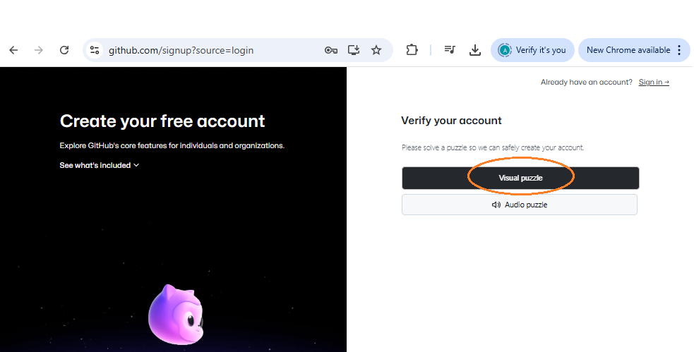

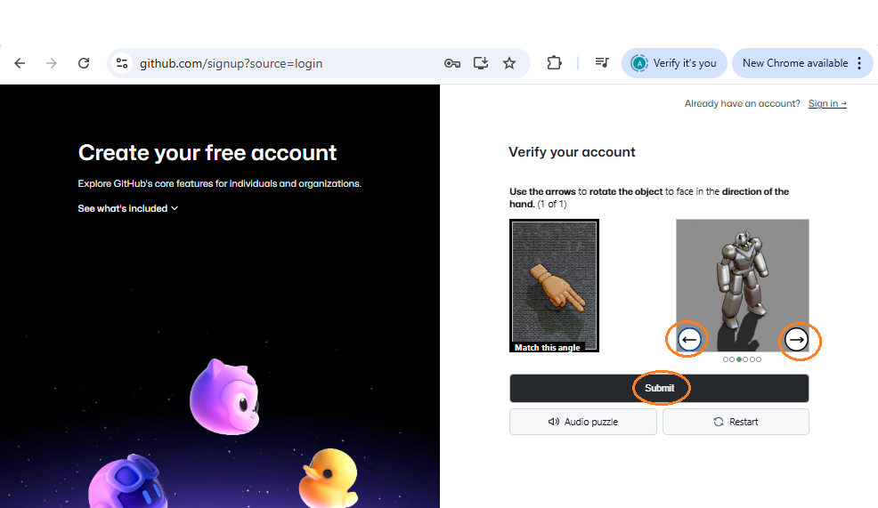

If we pass the step the program will give us to verify our code that was sent to our email (the previous email, [aaaaakom@outlook.com](mailto:aaaaakom@outlook.com))

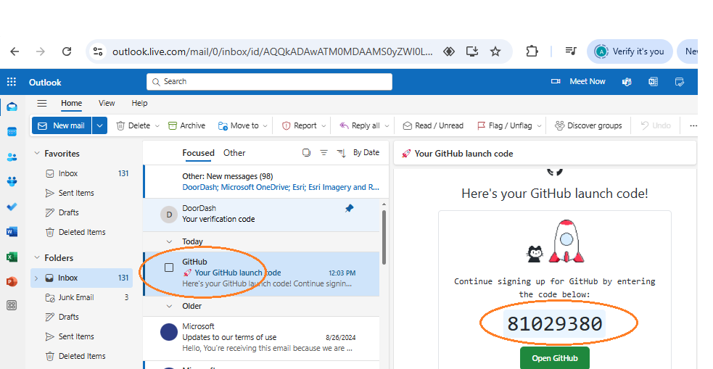



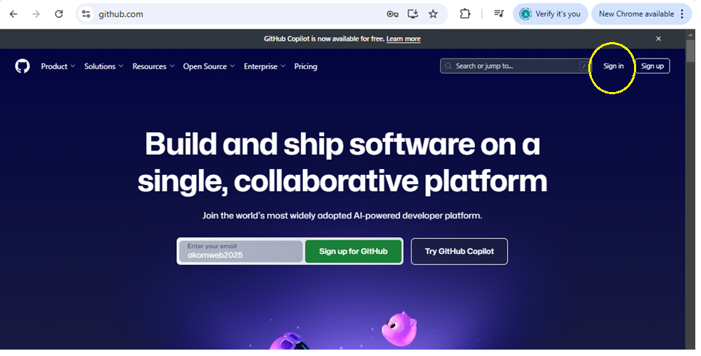

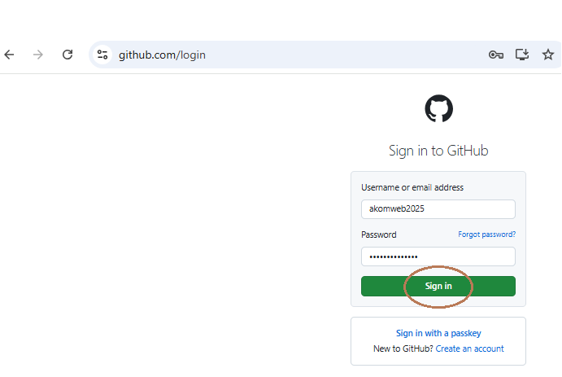

**Step 2: Create a new repository**

Next, you need to create a new repository to host your website. To create a new repository, click on the **“Create repository”** button on your left section after the new registration. You can also do it by clicking on the**“new”** button on your GitHub Dashboard. Give your repository a name that corresponds to your username. For example, if your website is called**“username”**, name your repository**“username.github.io”**.

A repository contains all of your code, your files, and each file's revision history. You can discuss and manage your work within the repository. A repository is the most basic element of GitHub. It's a place where you can store your code, your files, and each file's revision history. Repositories can have multiple collaborators and can be either public or private.

**Repository terminology:**

| **Term** | **Definition** |
| --- | --- |
| **Branch** | A parallel version of your code that is contained within the repository, but does not affect the primary or main branch. |
| **Clone** | To download a full copy of a repository's data from GitHub.com, including all versions of every file and folder. |
| **Fork** | A new repository that shares code and visibility settings with the original "upstream" repository. |
| **Merge** | To take the changes from one branch and apply them to another. |
| **Pull request** | A request to merge changes from one branch into another. |
| **Remote** | A repository stored on GitHub, not on your computer. |
| **Upstream** | The branch on an original repository that has been forked or cloned. The corresponding branch on the cloned or forked branch is called the "downstream." |

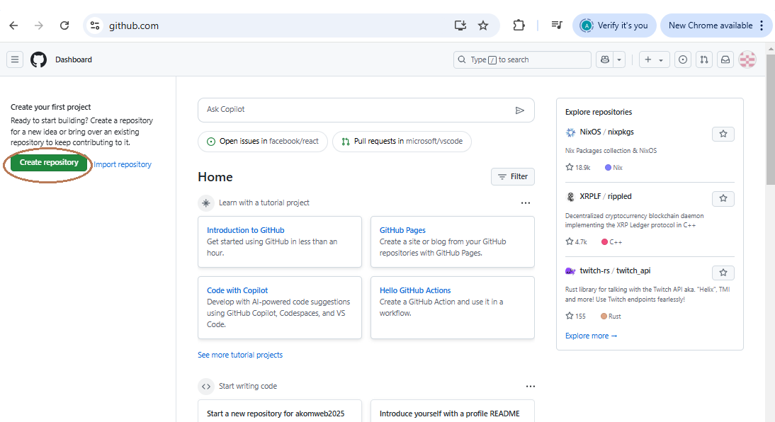

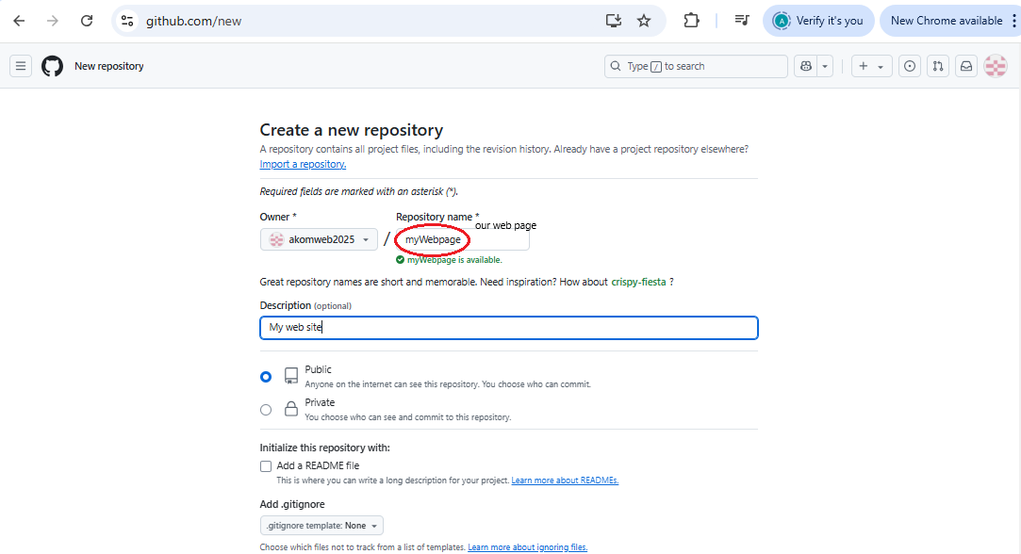

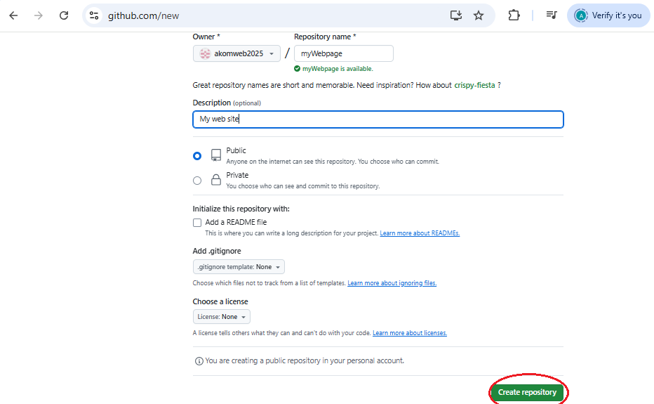

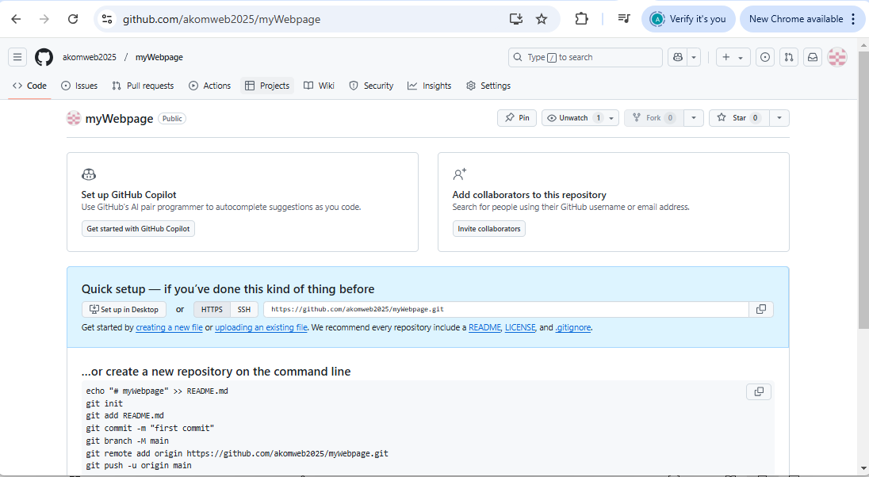

*Create new repository*

Give the description of the website you are creating and then click on **“create repository”**button.

*Name the repository as your username.github.io*

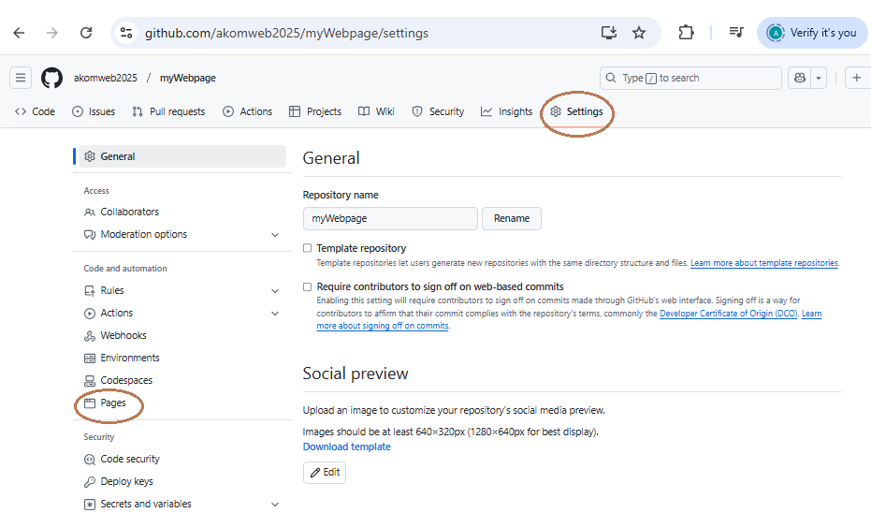

**Step 3: Create an index.html file and a web.css file**

To create a website, you need an HTML file that contains the content of your website. You can create a new HTML file using a text editor like Visual Studio Code or Notepad. Save the file as “index.html” in your local repository.

Or

Click on **” creating new file”**or**“new file”**to create a new file and name the created file.

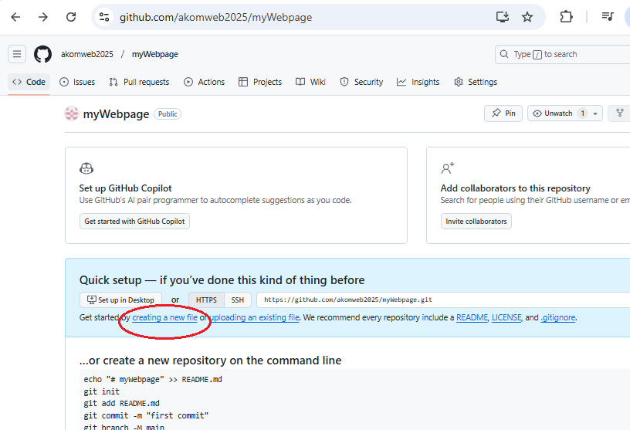

*Create new file*

Name the file with the **“.html”** extension so that you can add the HTML code for your website. Add the code for your website below in the edit section.

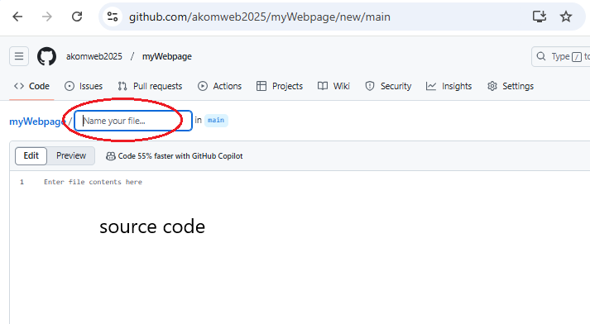

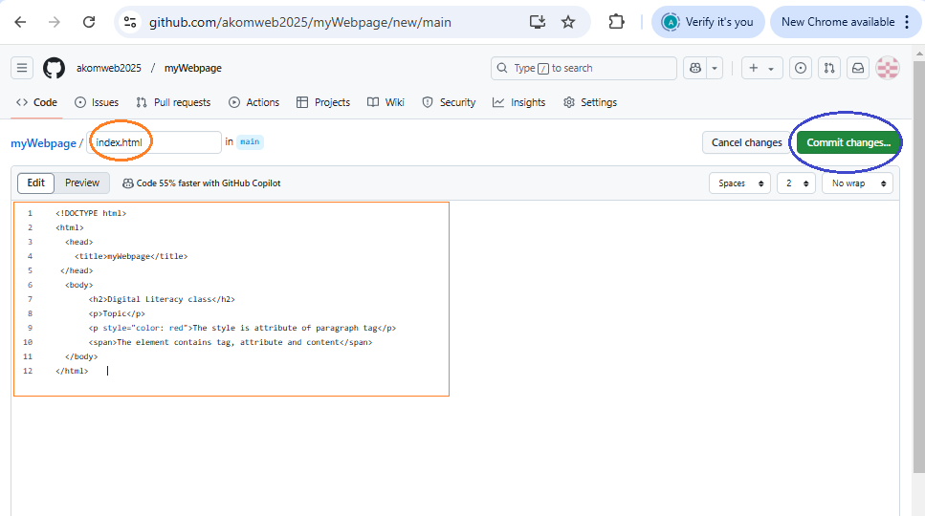

<!DOCTYPE html>

<html>

<head>

<title>myWebpage</title>

</head>

<body>

<h2>Digital Literacy class</h2>

<p>Topic</p>

<p style="color: red">The style is attribute of paragraph tag</p>

<span>The element contains tag, attribute and content</span>

</body>

</html>

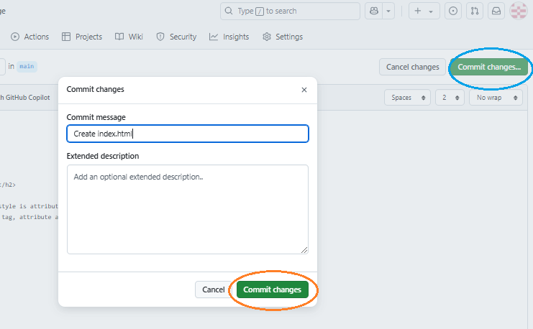

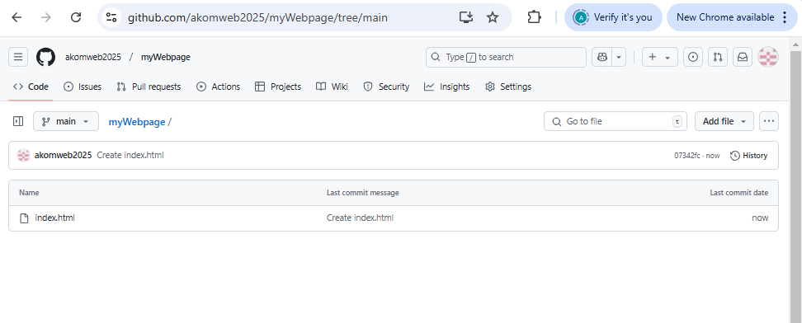

*Create index.html and add  the HTML code for your website*

Add a description and “**Commit changes”**button so that your code gets added and saved on GitHub.

*commit the  HTML code*

Add the CSS code for your website by doing the same process as above and then add a description and click on the **“Commit changes”**button.

*Create index.html and add  the CSS code for your website*

*Commit the CSS code*

**Step 4: Enable GitHub Pages**

After pushing your code to your repository, you need to enable GitHub Pages for your repository. To do this, navigate to your repository on GitHub and click on the **“Settings”** tab. Scroll down to the **“Pages”** section from the left section.

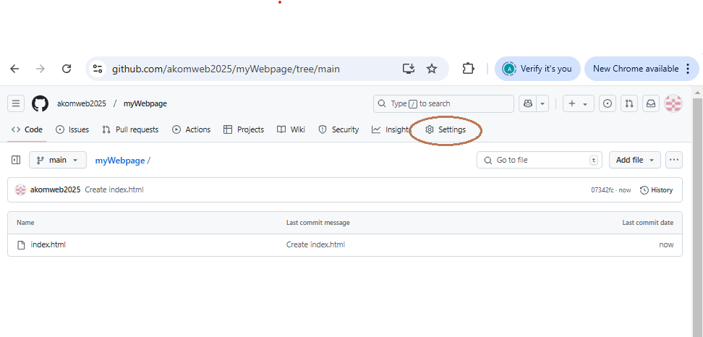

*Go to pages in the left section in the settings*

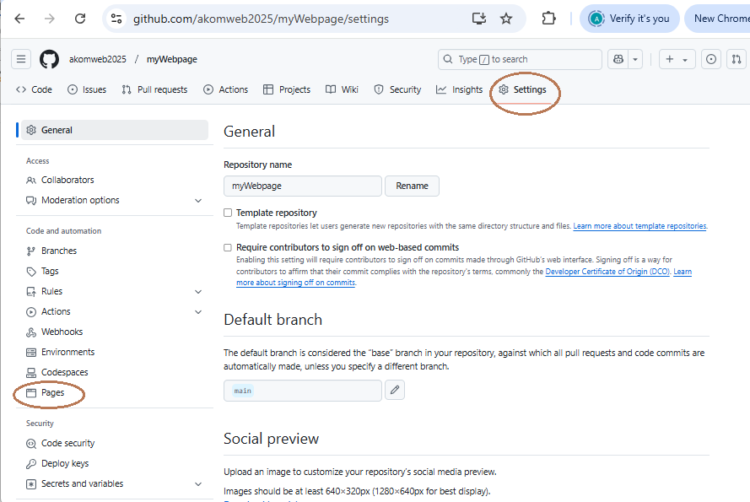

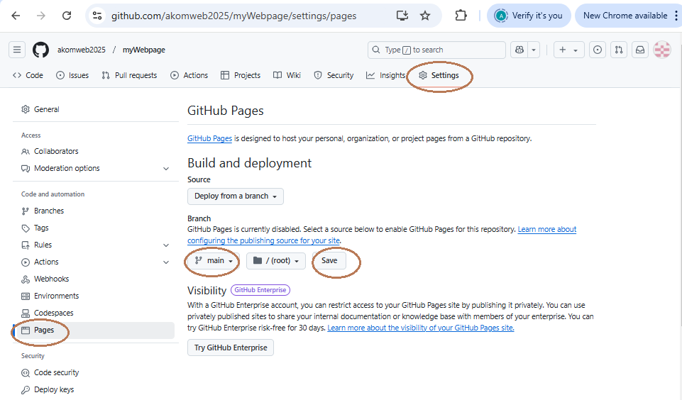

**Step 5: Visit your website**

Once GitHub Pages are enabled for your repository, your website is now live! You can visit your website by navigating to**https://your-username.github.io/**in your web browser. It might take a few moments for the changes to propagate and for your website to be accessible.

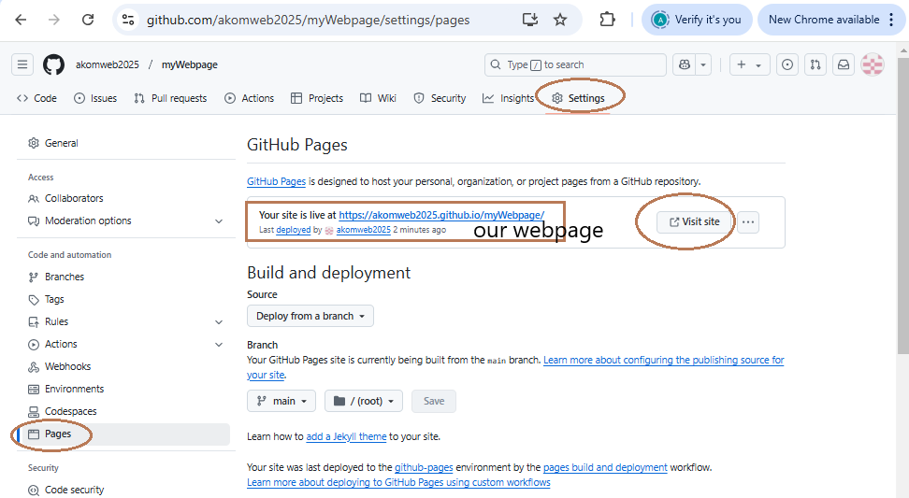

*Visit our hosted site*

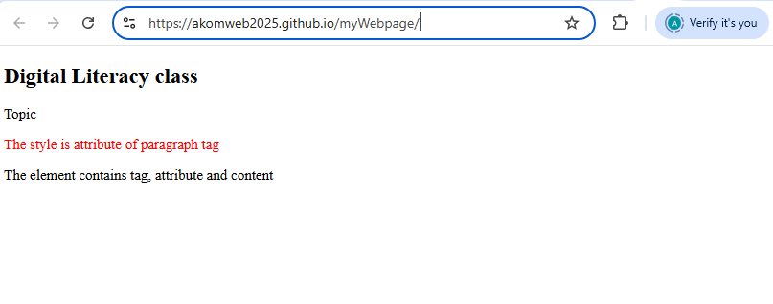

**2. Website creation**

Edit our website as follows:

**2.1 Desing our website**

The main webpage as shown below:

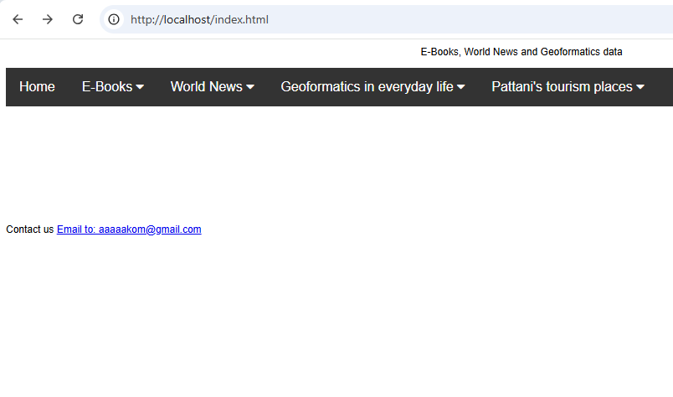

There are five menus including Home, E-books, World News, Geoinformatics in everyday life and Pattani’s tourism places. Each menu has links and documents to open as follows:

**Home**

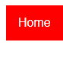 Nothing to link and open. Students have to write more program by yourself.

**E-books**

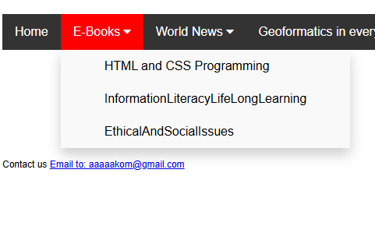

There are three commands to open E-books.

<div class="dropdown">

<button class="dropbtn">E-Books <i class="fa fa-caret-down"></i>

</button>

<div class="dropdown-content">

<a target="_blank" href="HTMLAndCss.pdf"> HTML and CSS Programming</a>

<a target="_blank" href="InformationLiteracyLifeLongLearning.pdf"> InformationLiteracyLifeLongLearning</a>

<a target="_blank" href="EthicalAndSocialIssues.pdf"> EthicalAndSocialIssues</a>

</div>

</div>

**World News**

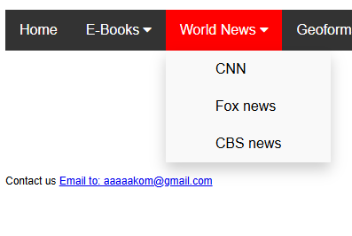

There are three News websites to link.

<a href="https://www.cnn.com" target="_blank"> CNN</a>

<a href="https://www.foxnews.com">Fox news </a>

<a href="https://www.cbsnews.com"> CBS news</a>

**Geoinformatics in everyday life**

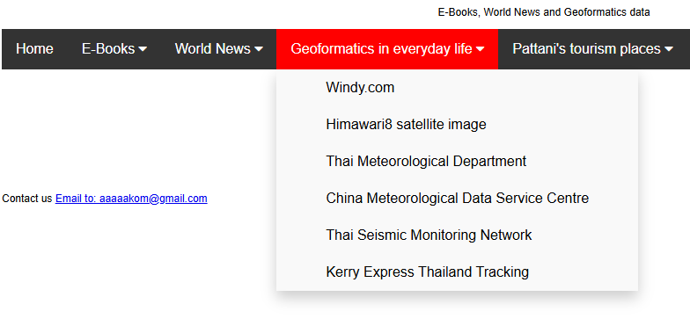

There are five links to connect.

<a href="https://www.windy.com">Windy.com</a>

<a href="https://himawari8.nict.go.jp/">Himawari8 satellite image </a>

<a href="https://www.tmd.go.th/">Thai Meteorological Department </a>

<a href="https://data.cma.cn/en"> China Meteorological Data Service Centre</a>

<a href="https://www.fdsn.org/networks/detail/TM/"> Thai Seismic Monitoring Network</a>

<a href="https://www.aftership.com/carriers/kerry-logistics"> Kerry Express Thailand Tracking</a>

**Pattani’s tourism places**

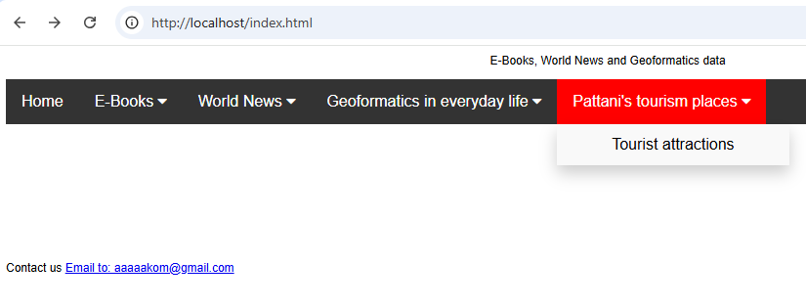

There is one link to open. This website is about Pattani tourism places (tourismplaces.html).

<div class="dropdown">

<button class="dropbtn">Pattani's tourism places <i class="fa fa-caret-down"></i> </button>

<div class="dropdown-content">

**<a href="tourismplaces.html">Tourist attractions</a>**

</div>

</div>

The details of “**tourismplaces.html"** file can be described as follows:

In this webpage we designed our website by dividing the webpage to 3 main sections the first section is the first header, the second section is slide bar and the third section is grid container this section was divided to 3 columns 5 rows with 9 sections as figure shown below:

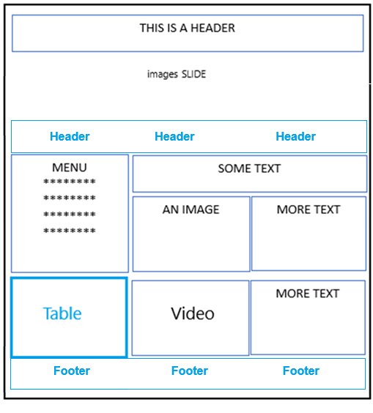

website

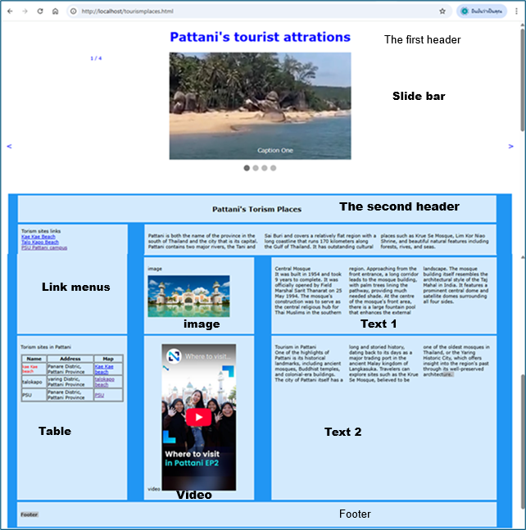

**Details of Website Layout:**

**1) Slide bar section:**

There are 4 slides with 4 pictures including kaekae_beach.jpg, talokapo_beach.jpg, pattani_bay.jpg and pattani_bar2.jpg.

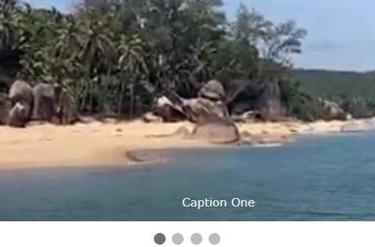 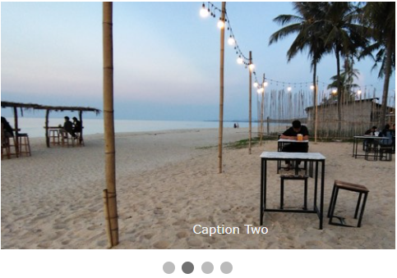

kaekae_beach.jpg talokapo_beach.jpg

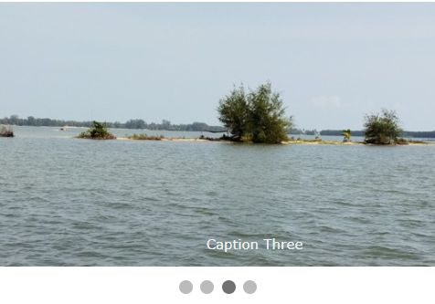 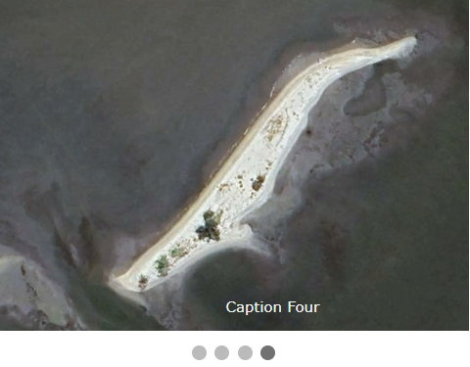

Pattani_bay.jpg pattani_bay2.jpg

Code:

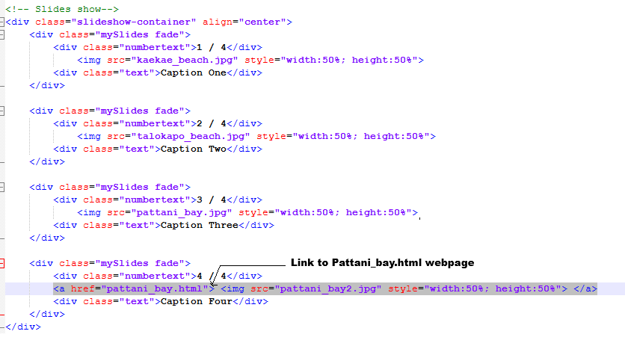

At slide no. 4 when users click at this picture to browser will link to pattani_bay.html website as shown below.

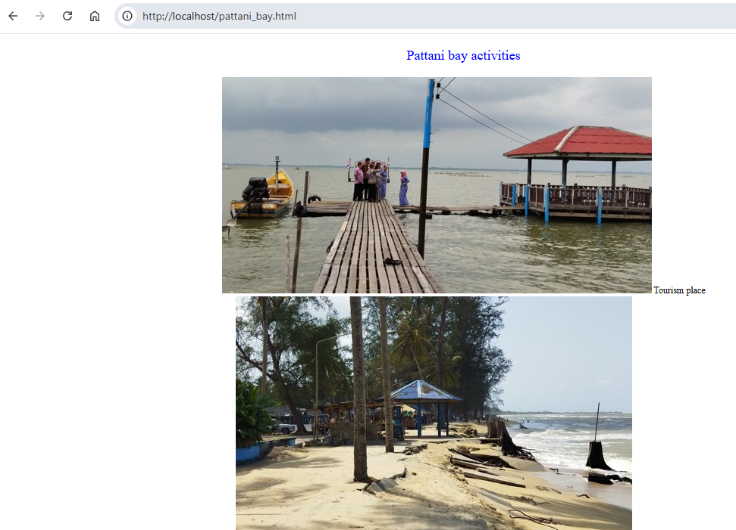

Code of this website:

<!DOCTYPE html>

<html>

<head>

<title>Pattani bay </title>

</head>

<body>

<p align="center" style="color:blue;font-size:18px" > Pattani bay activities </p>

<p align="center" >

<img src="tourist_attraction.jpg"> Tourism place </img><br>

<img src="coastal_erosion.jpg"> Coastal erosion </img><br>

<img src="fishing_boats.jpg"> Fishing boats </img><br>

<img src="mangrove_forest.jpg"> Mangrove forest </img><br>

<img src="coastal_fishery.jpg"> Coastal fishery </img><br>

<img src="marine_fishing_boat.jpg"> Marine fishing boat </img><br>

</p>

</body>

</html>

Diagram of webpage link:

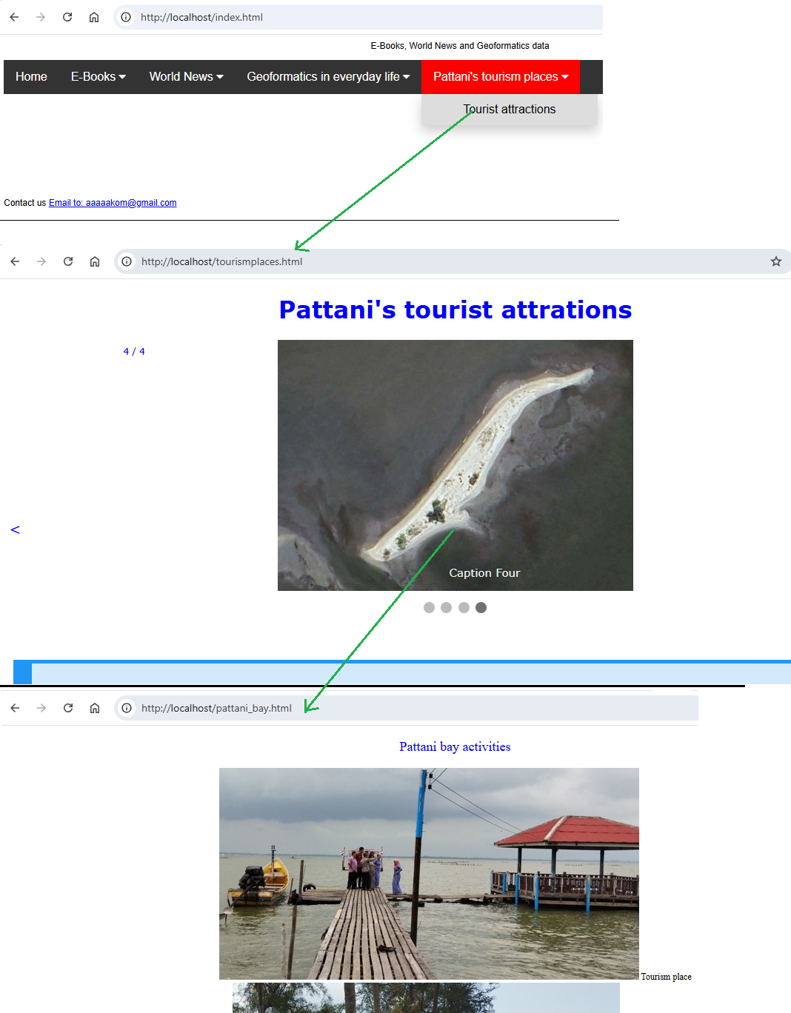

**Grid Layout Section:**

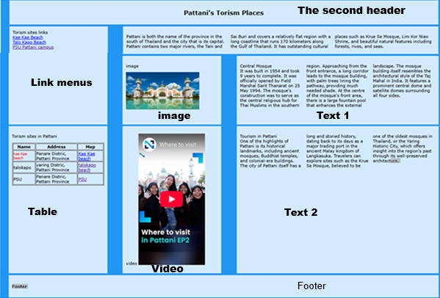

**Link menu section:** This section is about linking to tourism websites in this example there are 3 websites including Kae Kae beach website, Talo Kapo beach website and PSU Pattani campus websites as shown below.

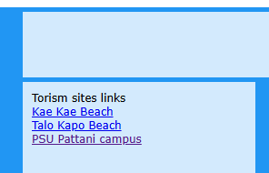

<a href="https://www.tourismthailand.org/Attraction/khae-khae-beach">Kae Kae Beach</a><br>

<a href="https://www.tourismthailand.org/Attraction/hat-talo-kapo-beach">Talo Kapo Beach</a><br>

<a href="https://www.psu.ac.th/pattani/">PSU Pattani campus</a></div>

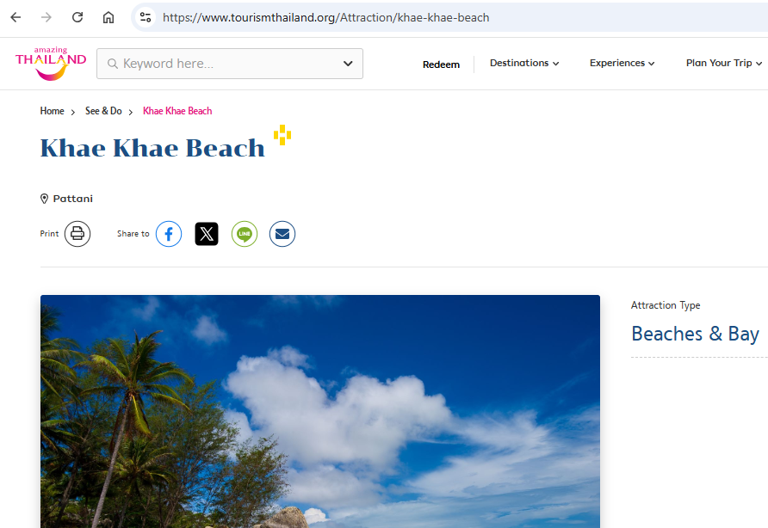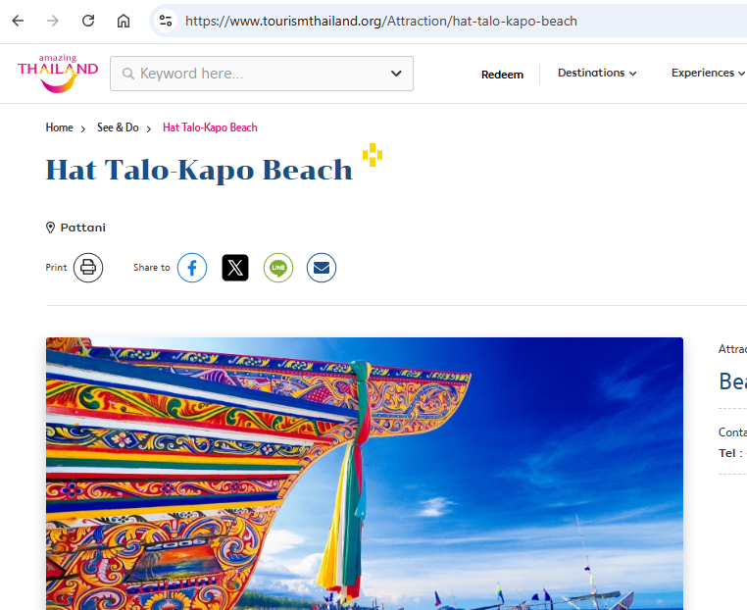



**Table section:** This section shows the tourism places by using tables format. There are 3 columns and three places as follows.

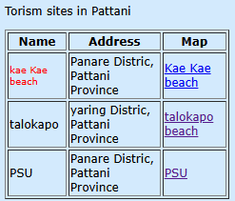

Code:

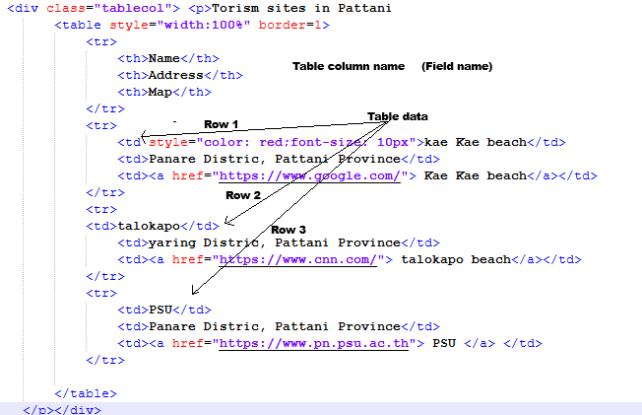

**Text 1 section:**

This section is divided into 3 columns as figure below.

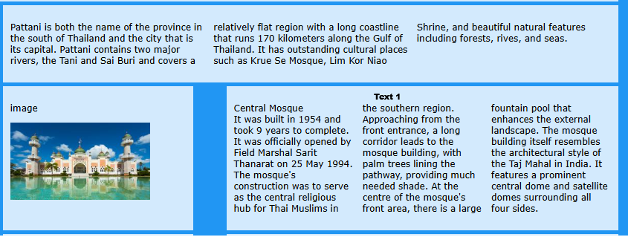

Code:

<div class="moretext" > <**p style="column-count:3; column-width: 20px**">Central Mosque <br> It was built in 1954 and took 9 years to complete. It was officially opened by Field Marshal Sarit Thanarat on 25 May 1994. The mosque's construction was to serve as the central religious hub for Thai Muslims in the southern region. Approaching from the front entrance, a long corridor leads to the mosque building, with palm trees lining the pathway, providing much needed shade. At the centre of the mosque's front area, there is a large fountain pool that enhances the external landscape. The mosque building itself resembles the architectural style of the Taj Mahal in India. It features a prominent central dome and satellite domes surrounding all four sides.

</p></div>

Another sections are normal.

**Image:**

<div class="imagecol"> <p>image</p> <img src="central_mosque.jpg" style="width:80%; height:60%"></div>

**Video:**

<div class="videocol"> <p>video

<iframe width="195" height="387" src="https://www.youtube.com/embed/neAkwdmCohs" title="Where to visit in Pattani EP2 | The Nation" frameborder="0" allow="accelerometer; autoplay; clipboard-write; encrypted-media; gyroscope; picture-in-picture; web-share" referrerpolicy="strict-origin-when-cross-origin" allowfullscreen></iframe>

</p></div>

**2.2 Edit our website on GitHub**

Now, we have three html files, 11 pictures, and three E-books. We must upload these files to our website (repository in GitHub). All files are in MS-team Folder Project.

|  |  |  |
| --- | --- | --- |
| **Html file** | **E-Book** | **Picture** |
| index.html | HTMLAndCss.pdf | kaekae_beach.jpg |
| tourismplaces.html | InformationLiteracyLifeLongLearning.pdf | talokapo_beach.jpg |
| Pattani_bay.html | EthicalAndSocialIssues.pdf | pattani_bay.jpg |
|  |  | pattani_bay2.jpg |
|  |  | central_mosque.jpg |
|  |  | tourist_attraction.jpg |
|  |  | coastal_erosion.jpg |
|  |  | fishing_boats.jpg |
|  |  | mangrove_forest.jpg |
|  |  | coastal_fishery.jpg |
|  |  | marine_fishing_boat.jpg |

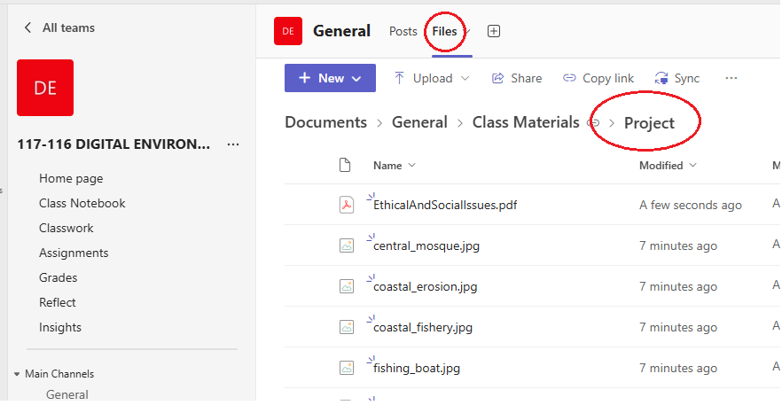

The best way to upload these files students should download to your mobile phone and upload to your own GitHub website.

Download file from MS-Team

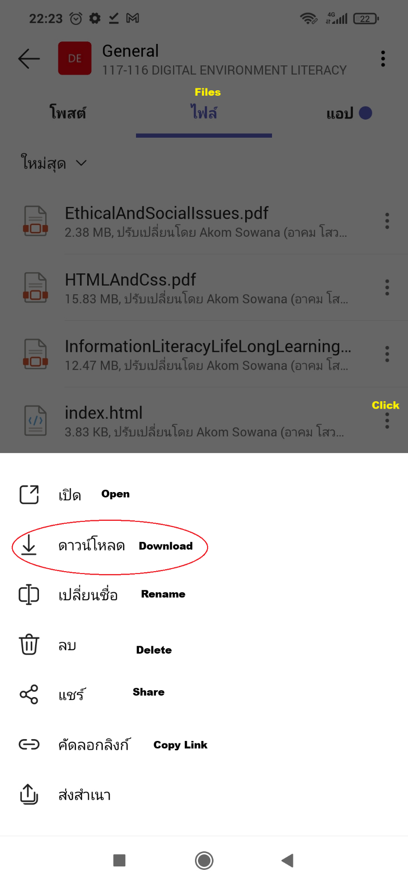

Open and download file with Mobile phone

Steps to edit our website:

1) Login to your GitHub website.

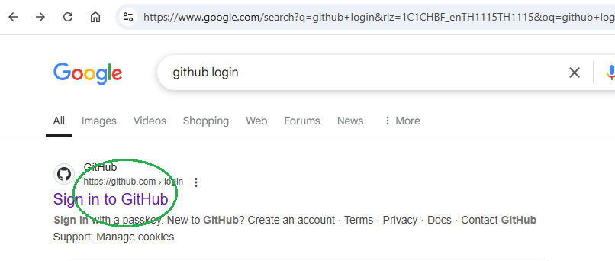

2) Goto our website

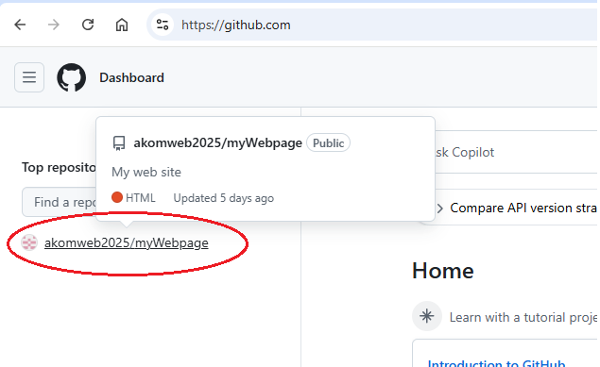

3) Rename the old index.html file

Goto your webpage and click “<> code” tab. Scroll down to index.html file and click.

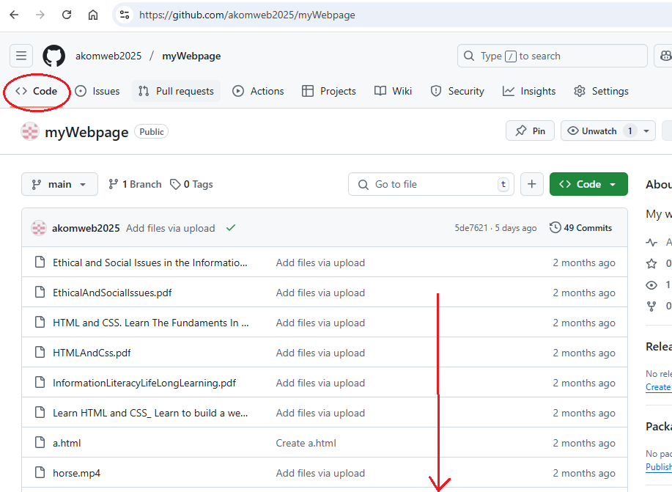

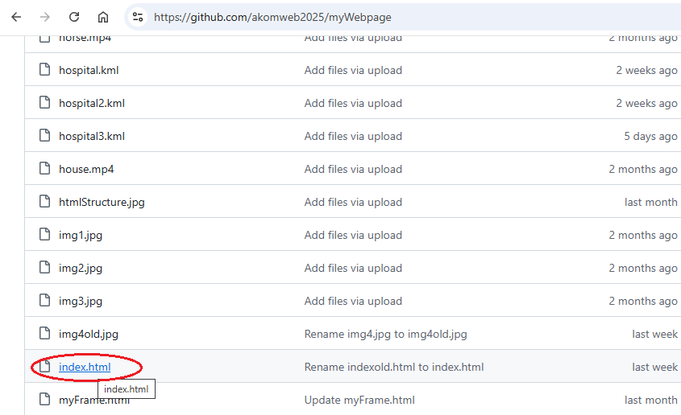

Rename to indexold.html as shown in figure below.

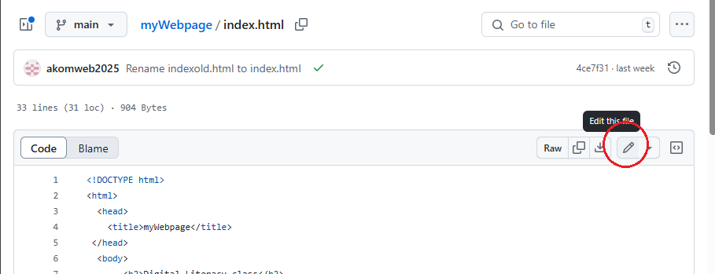

Change index.html to indexold.html and click commit changes.

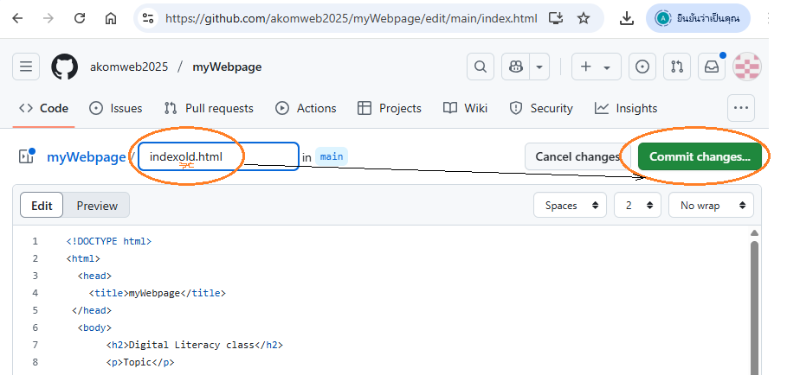

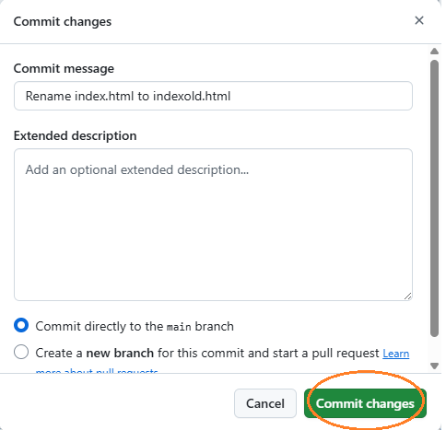

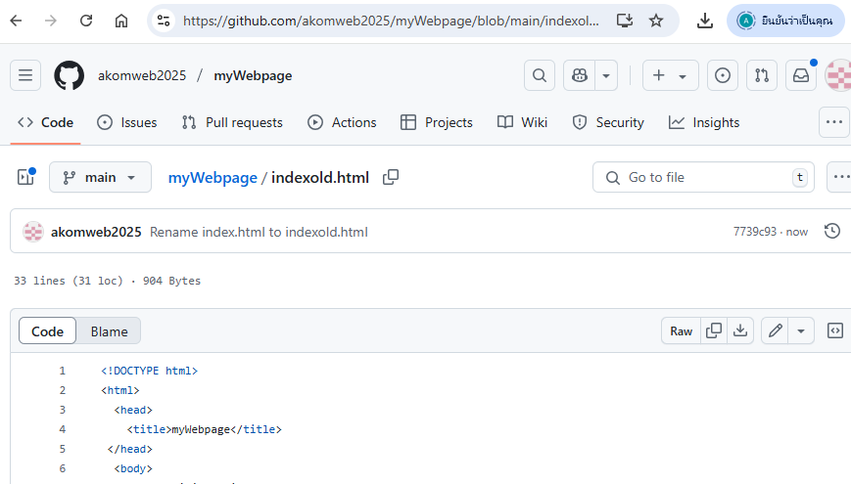

3) Upload all files to your repository (your website) and commit changes as mentioned above.

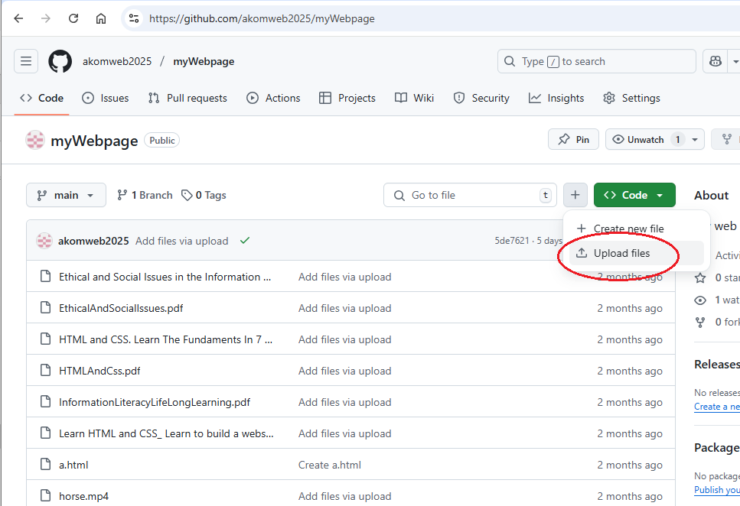

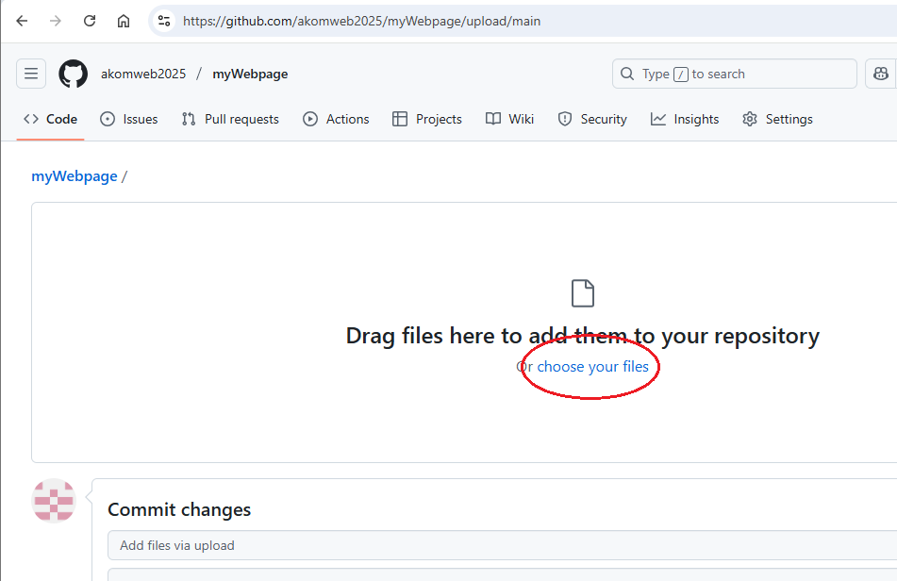

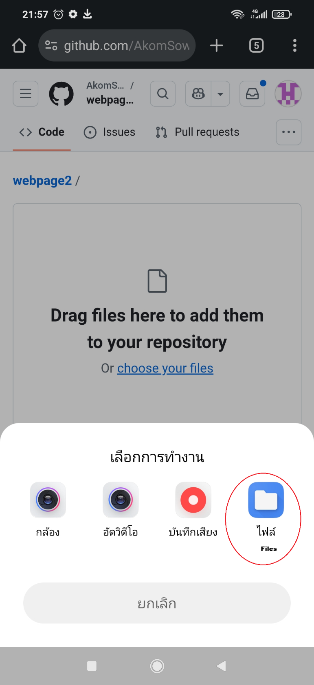 Android system

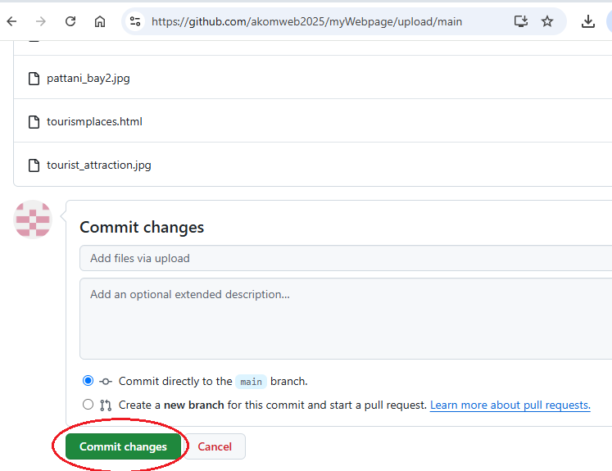

All files must be in this repository and check for the new index.html file has been uploaded as shown below.

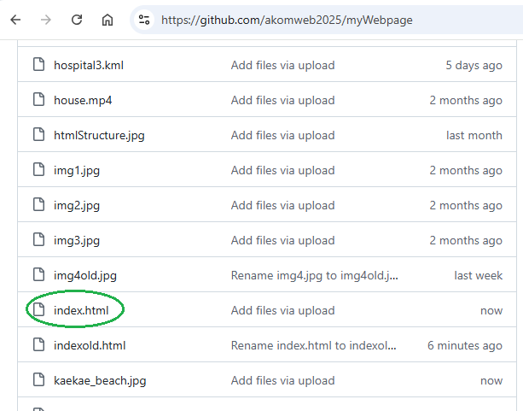

Goto your page (your website).

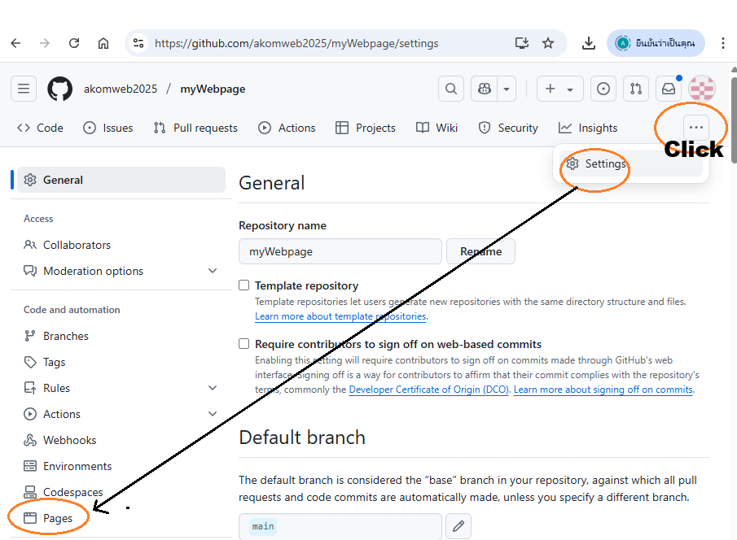

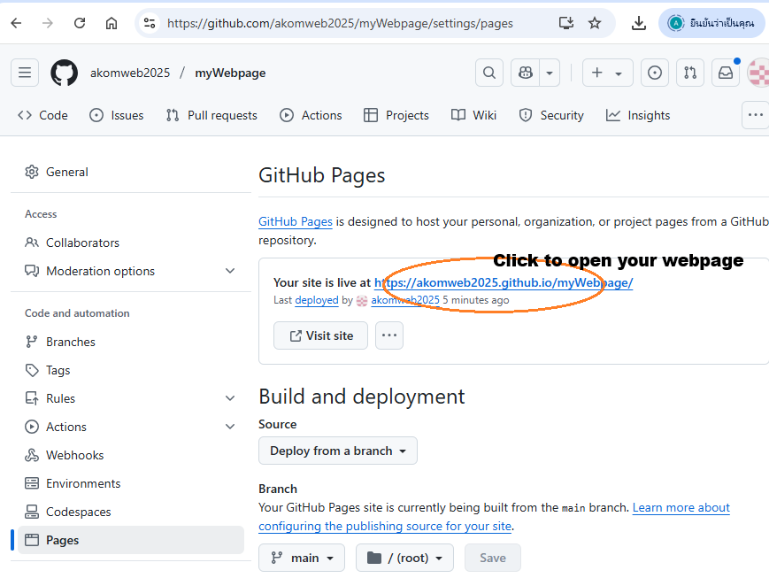

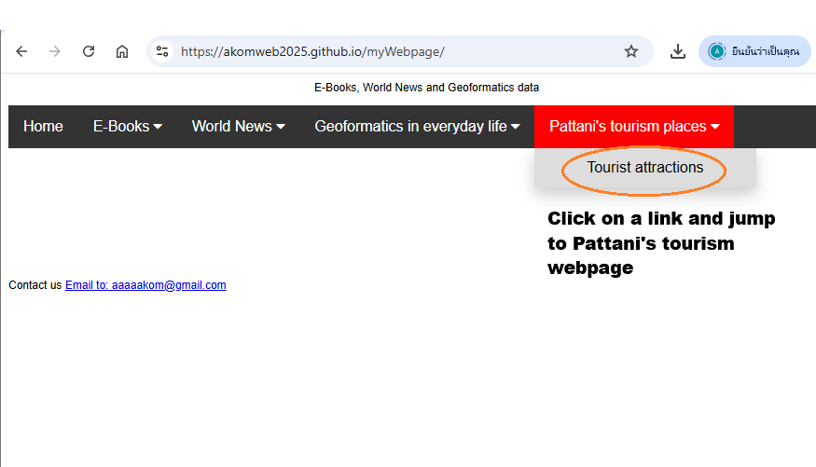

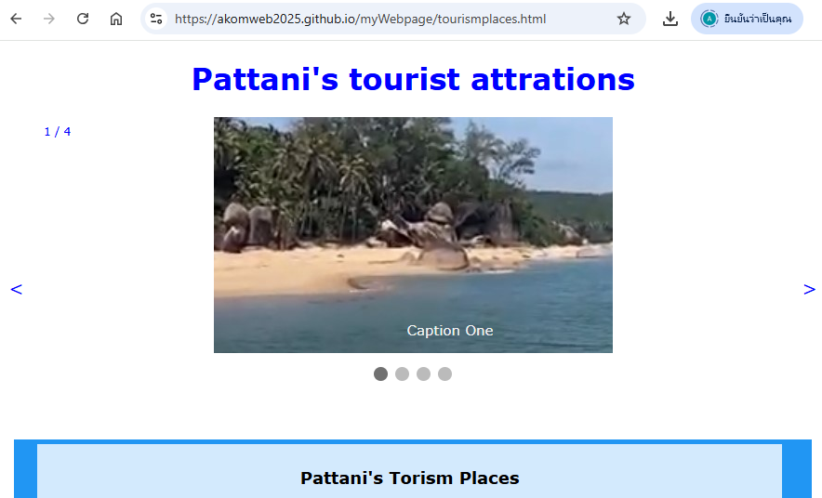

Click at slide number 4 to go to pattani_bay.html webpage.

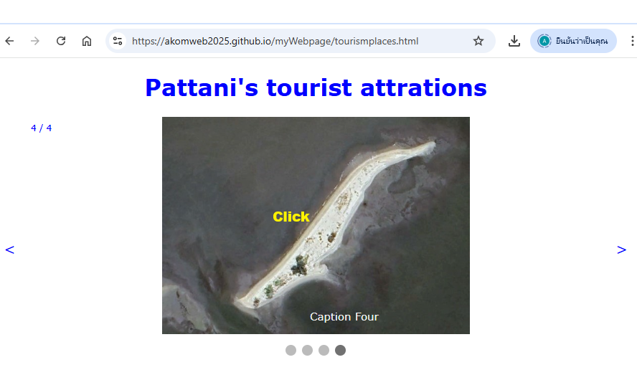

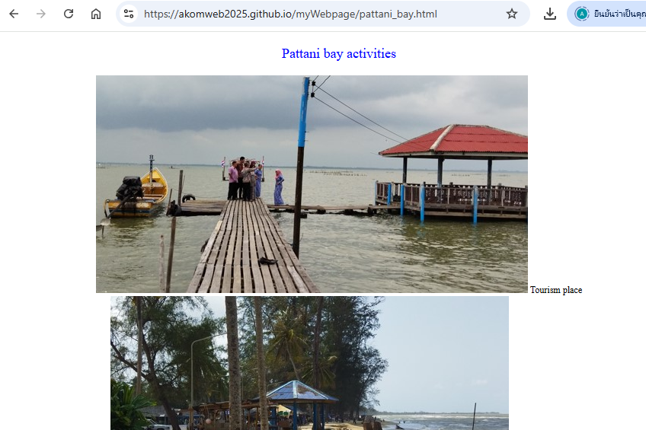

**Note:**

Everybody does this work to make your website. **For your group**, every group does this work and modifies the webpages for making a nice website such as change the web color, add more tourism places, and write more texts on the webpages. Your group score will be high if your group has a nice webpage. Send your group website to me ([akom.s@psu.ac.th](mailto:akom.s@psu.ac.th) or [aaaaakom@gmail.com](mailto:aaaaakom@gmail.com) or in MS-Team) before April 1, 2025.

Your website score is 10 points. Your group website score is 20 points.